Given a root of an N-ary tree, return a [**deep copy**](https://en.wikipedia.org/wiki/Object_copying#Deep_copy) (clone) of the tree.

Each node in the n-ary tree contains a val (int) and a list (List[Node]) of its children.

class Node {

public int val;

public List<Node> children;

}

*Nary-Tree input serialization is represented in their level order traversal, each group of children is separated by the null value (See examples).*

**Example 1:**

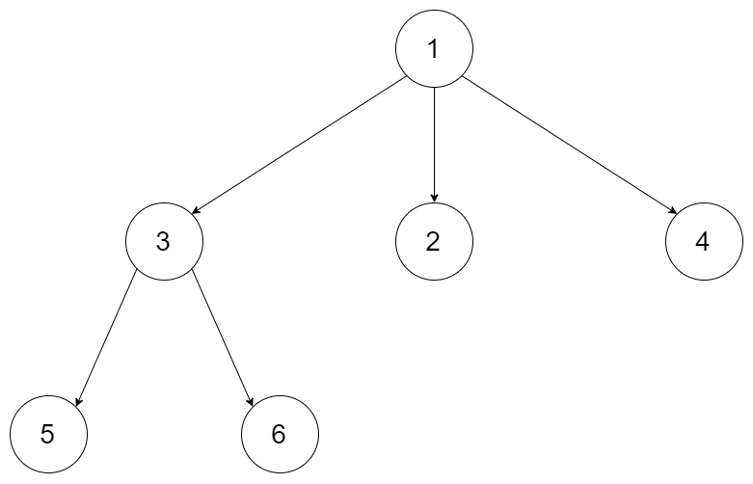

**Input:** root = [1,null,3,2,4,null,5,6]

**Output:** [1,null,3,2,4,null,5,6]

**Example 2:**

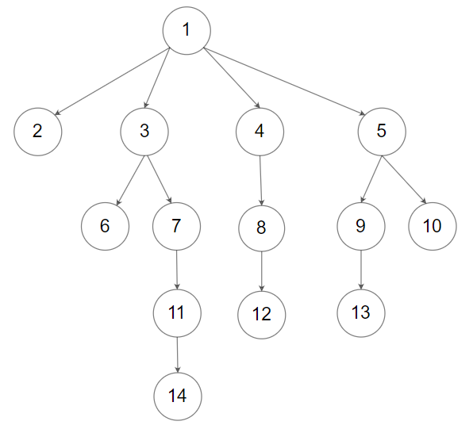

**Input:** root = [1,null,2,3,4,5,null,null,6,7,null,8,null,9,10,null,null,11,null,12,null,13,null,null,14]

**Output:** [1,null,2,3,4,5,null,null,6,7,null,8,null,9,10,null,null,11,null,12,null,13,null,null,14]

**Constraints:**

* The depth of the n-ary tree is less than or equal to 1000.
* The total number of nodes is between [0, 104].

**Follow up:**Can your solution work for the [graph problem](https://leetcode.com/problems/clone-graph/)?